**Candidate Guidance**

**Our commitment**

At Portsmouth City Council we are committed to ensuring a transparent recruitment process for every candidate at every level. We value diversity, are open, fair and provide equal opportunity to all. We adhere to the Equality Act 2010, in all aspects of employment policies and procedures as well as having due regard to the need to eliminate unlawful discrimination and advance equality of opportunity.

**Create a Candidate Profile**

When you apply for a role with us, you will be asked to create a profile using our Profile Builder. This will allow you to log back in, update your details, track your existing applications, complete any tasks assigned to you, and apply for other roles with us.

When you click **apply** on the job advertised on our career site , you will be taken to a screen similar to this one below.

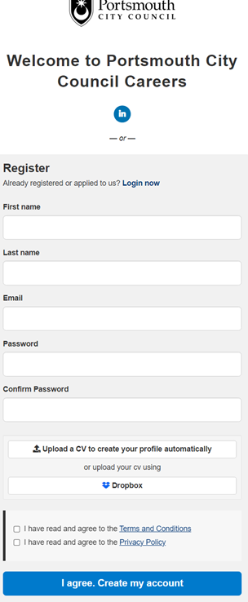

**Managing your candidate profile in our recruitment system**

Once you’ve set up your account you can log in at any time to see the progress of your applications and a record of the email communications we have sent to you.

It’s easy to manage your details in our recruitment system.

**You can:**

- Update your personal details for example if you change address

- Update the newest version of your CV

- Change your GDPR preferences 'Opt ins'

- Manage your interview bookings

- View your job offer and fill out any related information we have asked you to complete.

**Application Process**

**Anonymised recruitment process**

When we receive your application, all personal details including name, date of birth, nationality, contact information and address are all anonymised. Our hiring managers will review your skills, qualifications and experience alongside your personal statement to determine your suitability for the role. After shortlisting has taken place and invitations to interview have been sent out, those personal details will then become visible.

To help us maintain this commitment, whilst you can add your CV to your profile, however, with our anonymised recruitment process, we cannot view them on your application, therefore, we ask all candidates to create a profile through our career's portal using the profile builder tool.

For all safeguarding roles we ask you to provide a full education/career history and explain any education/career gaps.

As part of the application process, you will need to demonstrate you have the Right to Work in the UK.

**Completing your application - Personal Statement**

As part of your application we ask that you complete a personal statement to demonstrate how you meet the criteria for the role.

This section is crucial and is where you must demonstrate how you meet the requirements of the job. Our managers will use this information to shortlist your application form and measure your suitability and determine if you have the right skills, abilities and experience.

• Make sure, when writing your personal statement, that your response is in line with the criteria under the heading **Who is the person** on the job profile.

• Align your skills and experience, keep it relevant and succinct. It’s important to attract the hiring manager’s attention, which means putting most emphasis on skills and experience that are specifically relevant to the job.

**How we will keep in touch with you**

Once you have a careers account with us, we will primarily contact you via email and often we will prompt you to log into your careers account where you’ll see an easy to navigate dashboard of all your applications.

Please ensure the email you have provided to set your account up is correct so we can get in touch with you.

**Interviews hints and tips**

When you attend an interview or assessment with us, we want to give you the best opportunity to show us your skills and experience so we’ve put together a few pointers to help you prepare.

**Where is the interview being held –** if it’s in person, check the route, plan your journey, where will you park. If online, have you got your joining link, are you using a laptop or a phone – is it full charged?

**Task, presentation or assessment –** were you asked to prepare a presentation for your interview? Have you been sent an assessment or task to complete?

Make sure you check the invite and email to see if there were any other elements to complete or prepare.

**Review the advert, job description & company website –** it’s always good to remind yourself of the key things the role needs from you and also what the values of the organisation are. This can help you see how you’ll fit into the organisation and which of your skills are going to add the most value for the employer.

**Successful candidates**

**Conditional Offer and Pre-employment Checks**

If you are successful, we will send your conditional offer and information relating to any pre-employment checks that need to be completed.

You will be asked to complete a series of onboarding forms and provided details of referees

You can help us get your referencing completed without delay by making sure you:

- Provide reference details for your full 5 years work history

- Provide valid contact details for your referees including email address and contact number

- Advise your referees where possible to expect our reference request on email initially

**Please note that references from relatives or friends are not acceptable.**

**Contract of employment**

On completion of satisfactory pre-employment checks, we will contact you to confirm your start date. You will then receive your contract of employment which you should read and sign to confirm your acceptance of the role.

**Support**

If you require any support along the application process, please contact [recruit@portsmouthcc.gov.uk](mailto:recruit@portsmouthcc.gov.uk) and one of the recruitment team will be more than happy to assist.